**Experiment -1.3**

To Create and Explore pull request.

**Student Name: Sandhya Kumari UID: 22bdo10074**

**Branch: CSE (DevOps) Section/Group: 22BCD-1(B)**

**Semester: 4 Date of Performance:2|2|2024**

**Subject Name: Git and Git-Hub Subject Code: 22CSH-293**

#### 1. Aim/Overview of the practical: To create and explore Pull request.

**2 Task to be done:** Inthis experiment, we have to make one repository on git-hub, then clone, make branch, add file, after adding file in local repository then push to remote repository then make some update on git-hub after this you can fetch and make pull request.

**3. Steps for experiment/practical:**

1. Make repository on git-hub named as ExpThree.

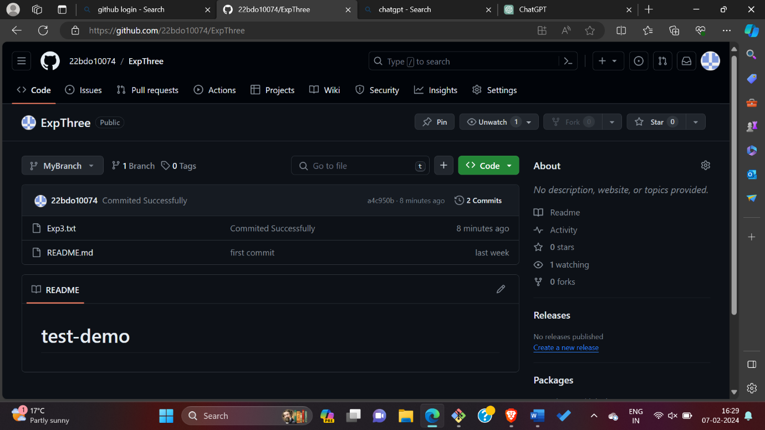

1. **To initialize a new Git repository in your current directory, you can use the command git init.**

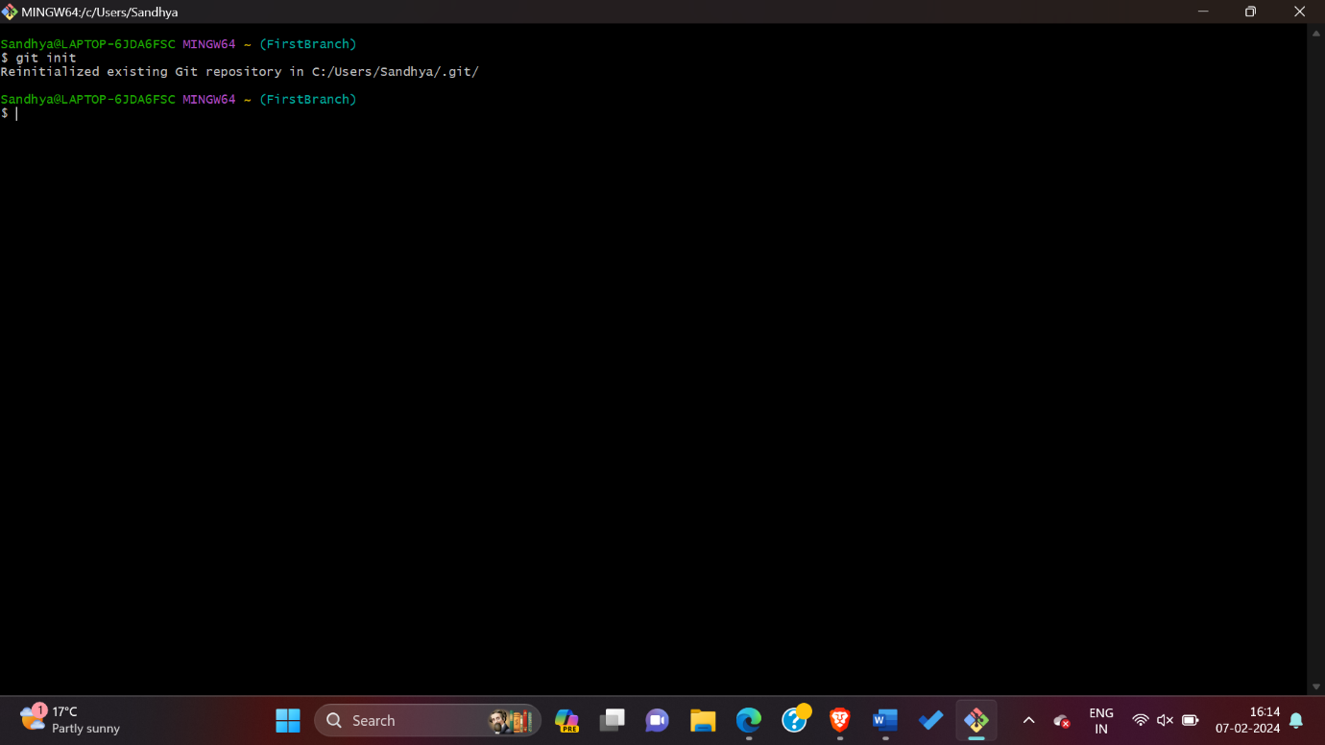

1. **Open git-bash CLI, then write git command for cloning as**

**$ git clone “** [**https://github.com/22bdo10074/ExpThree.git**](https://github.com/22bdo10074/ExpThree.git)**”**

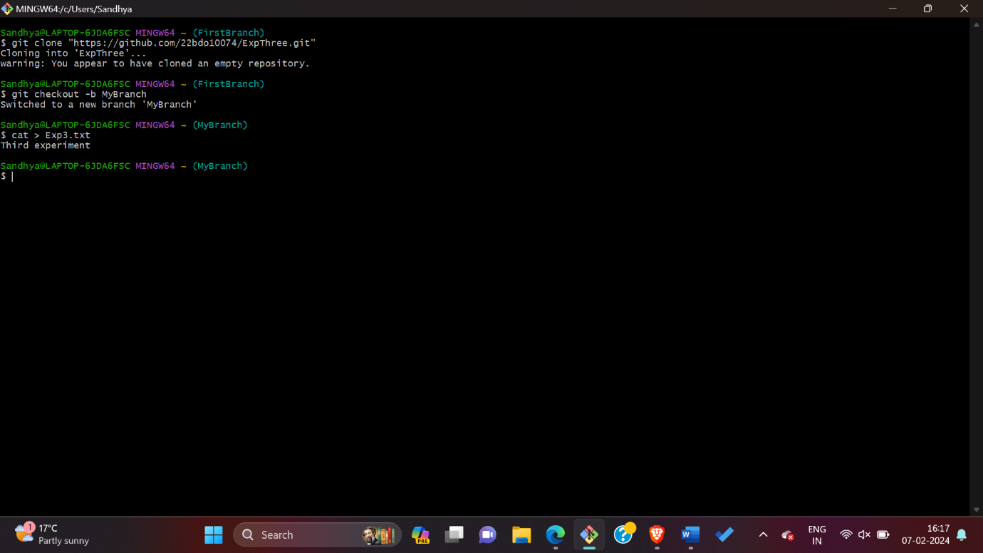

1. **Make branch and use checkout command to switch to another branch.**

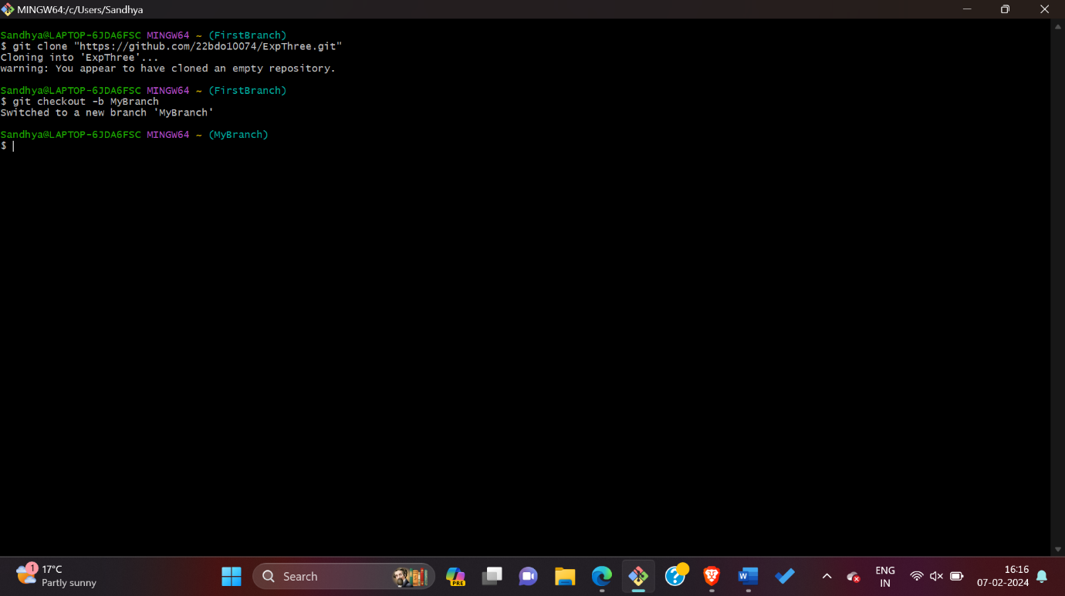

1. **Create file and use command as cat> Exp3.txt also check what is there in this file by using command as cat Exp3.txt.**

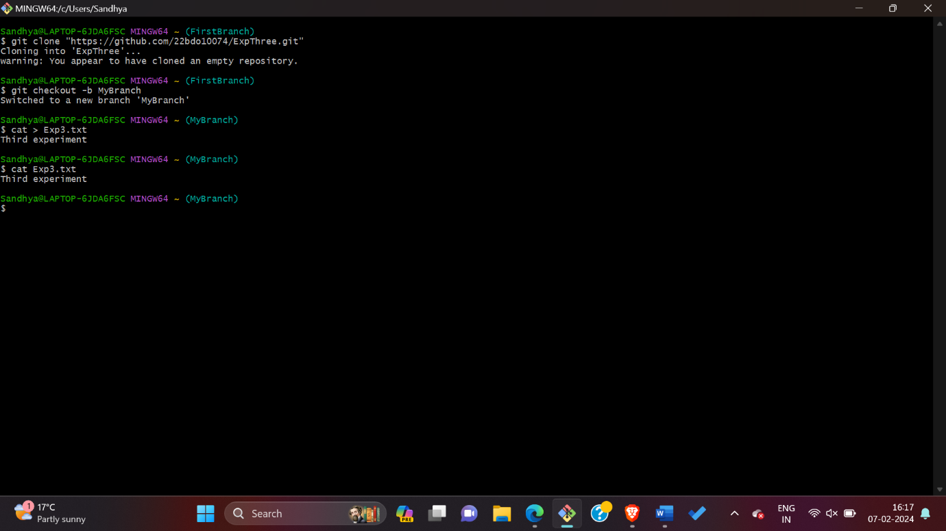

**6) Add file and then commit it by using git command as git commit -m “any message” .**

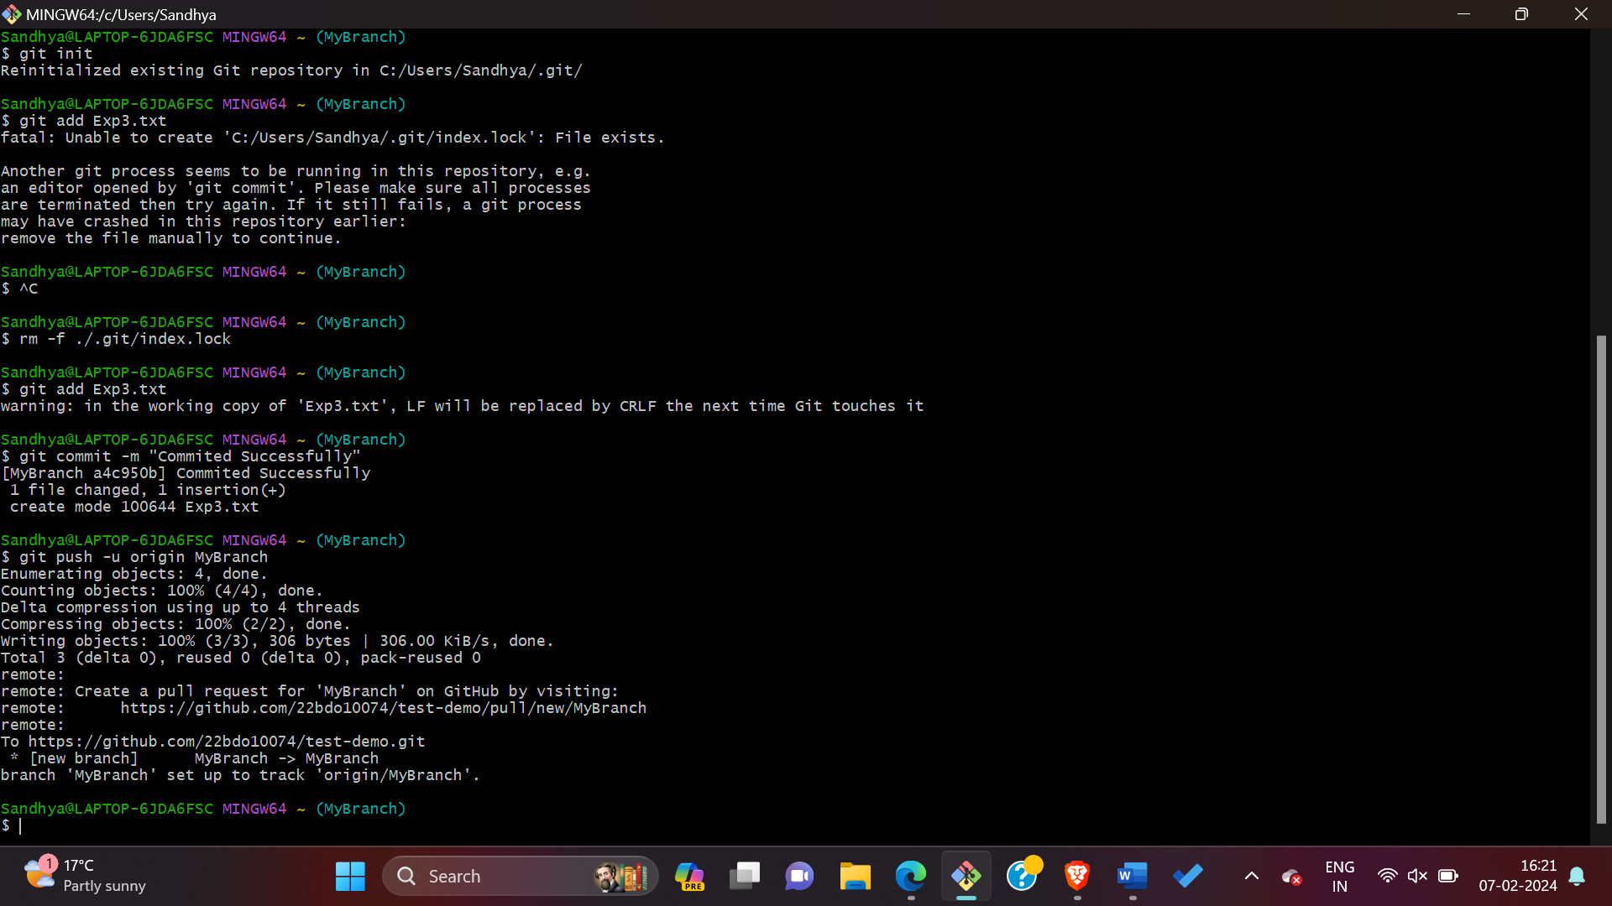

1. **Push this Branch to another branch on git-hub by using command as $ git push -u origin MyBranch.**



1. **To merge branches in Git, you can use the git merge command also To fetch changes from a remote repository in Git, you can use the git fetch command.**

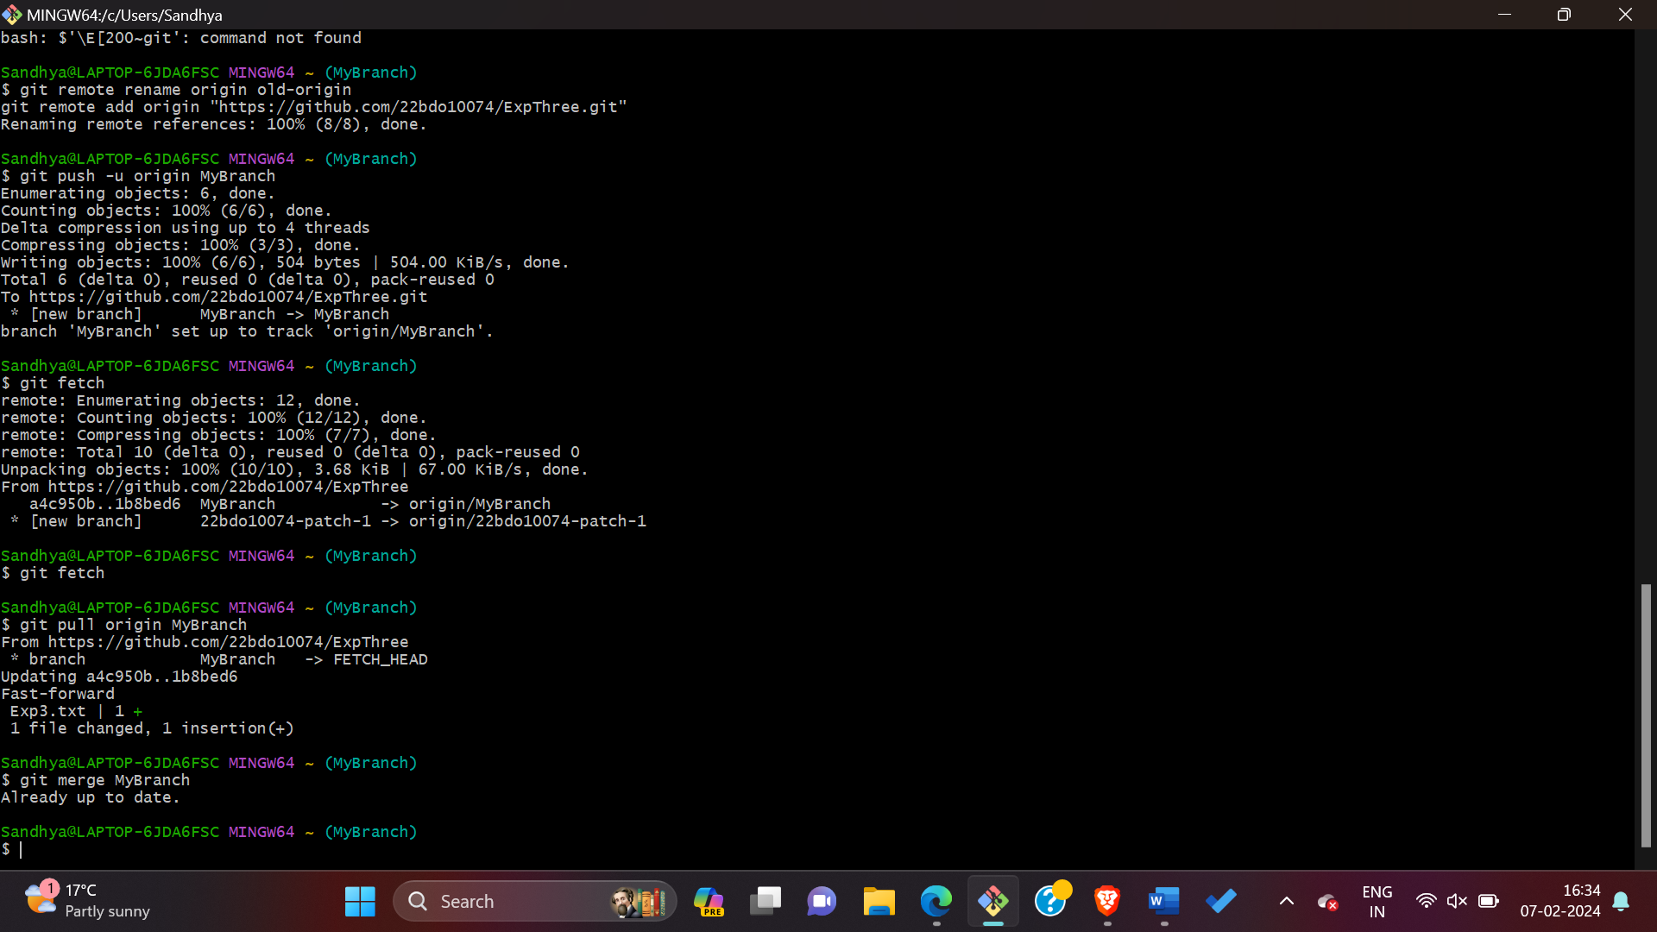

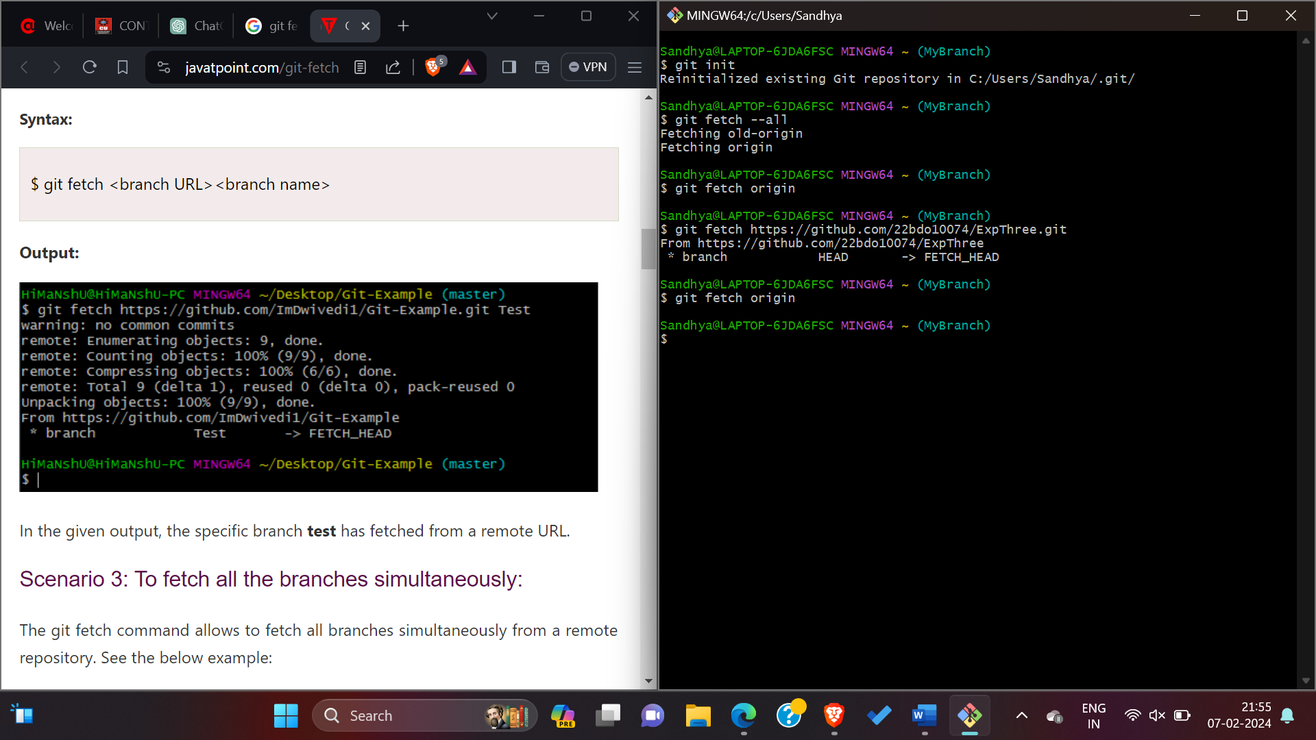

1. **Create a Pull Request:**

* **After pushing your changes, go to your forked repository on GitHub.**
* **You should see a prompt to create a pull request for the branch you just pushed.**
* **Click on the "Compare & pull request" button.**
* **Provide a descriptive title and description for your pull request, explaining the changes you've made.**
* **Review the changes in the pull request and make sure everything looks correct.**
* **Click on the "Create pull request" button to submit your pull request.**

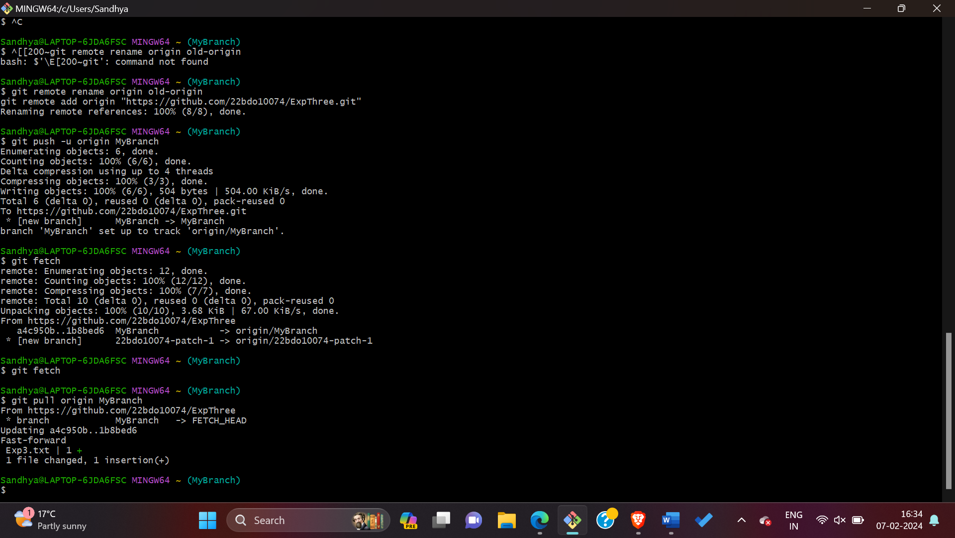

1. **Go to Git-Hub account then check all the updates.**

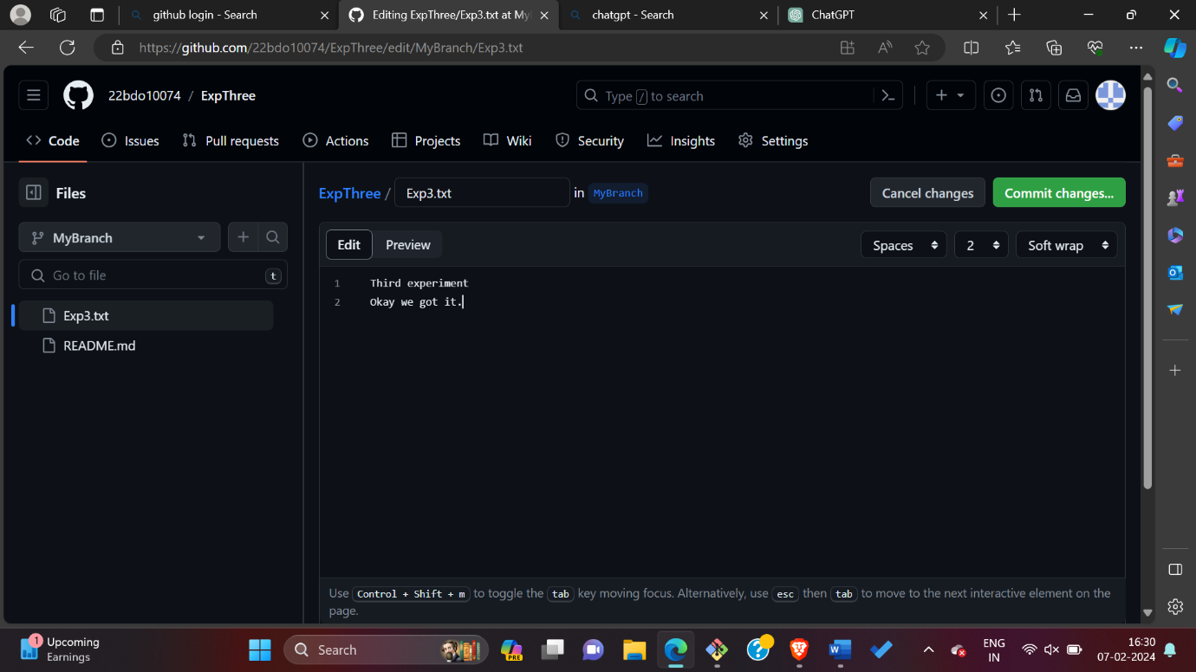

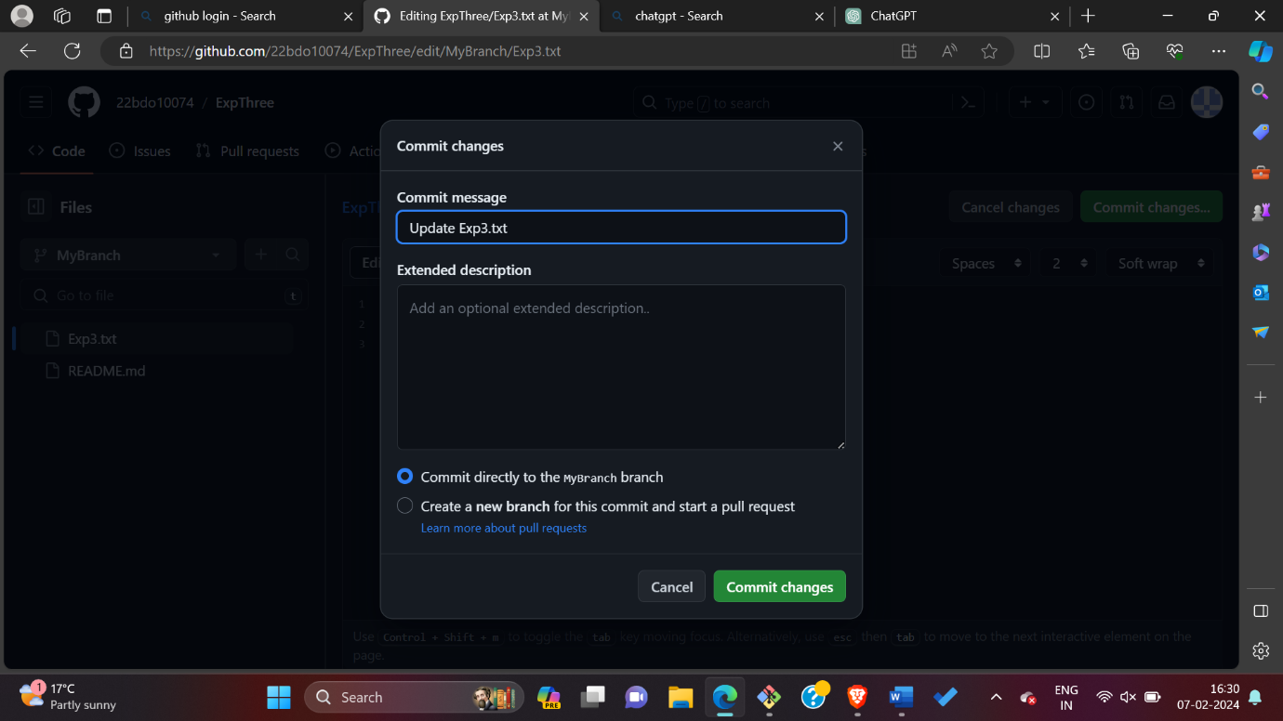

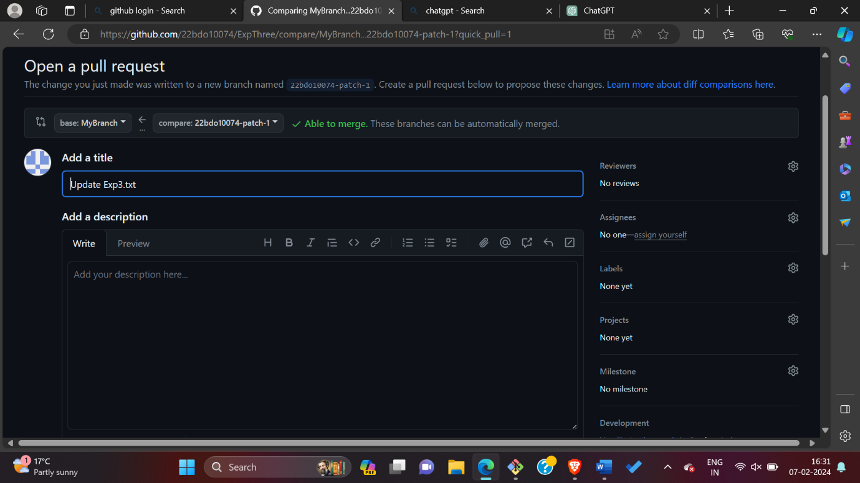

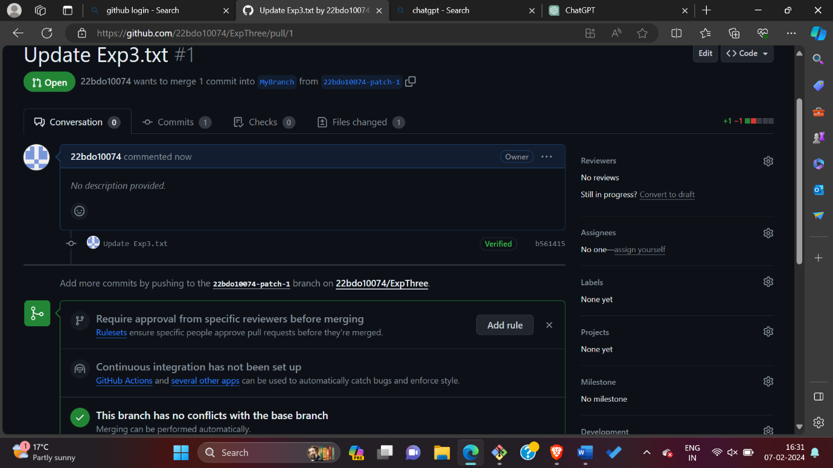

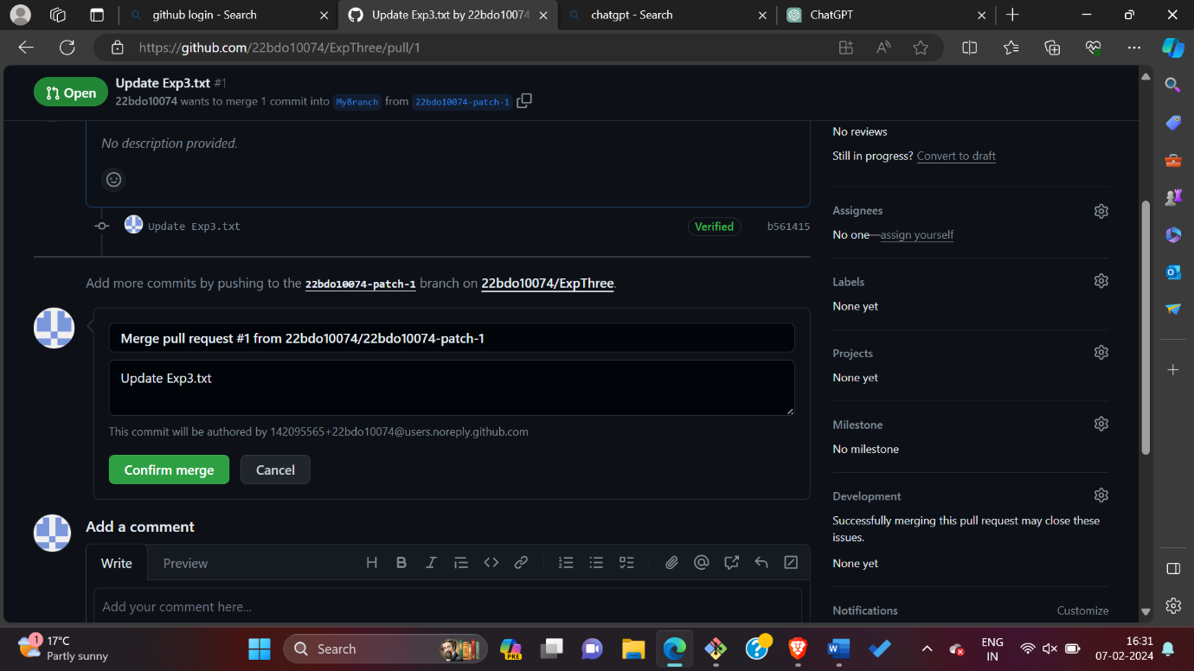

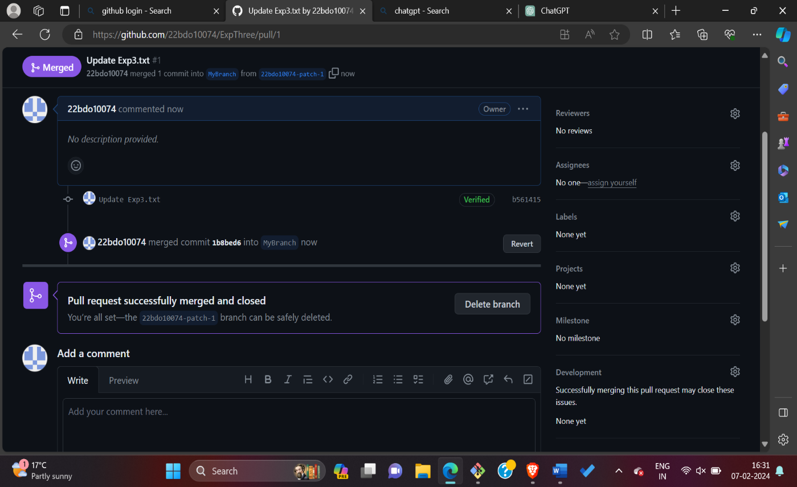

**11). Observations/Discussions:** It focused on creating and exploring pull requests could include insights and reflections on various aspects of the process.

**12). Result/Output/Writing Summary:** The result or output of the experiment to create and explore pull requests would be the successful creation and merging of pull requests in the Git repository.

**Learning outcomes (What I have learnt):**

**1.It focused on creating and exploring pull requests.**

**2. Learnt about how to clone form repository.**

**3. Learnt about how to merge branch.**

**4. Learnt about how to make push and pull requests on git-hub account.**

**5.Learnt about how to fetch origin using git command.**

**Evaluation Grid (To be created as per the SOP and Assessment guidelines by the faculty):**

|  |  |  |  |
| --- | --- | --- | --- |
| Sr. No. | Parameters | Marks Obtained | Maximum Marks |
| 1. |  |  |  |
| 2. |  |  |  |
| 3. |  |  |  |
|  |  |  |  |